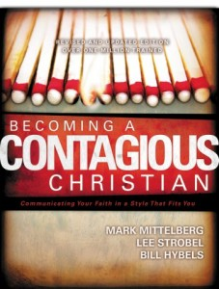
What is your evangelism style?
In the book, Becoming a Contagious Christian, Bill Hybels and Mark Mittleberg point out that there are a variety of different evangelism styles.
- Confrontational: Peter, Acts 2.
- Intellectual / Philosophical: Paul, Acts 17.
- Testimonial: Blind Man, John 9
- Invitational: Woman at the Well, John 4
- Serving: Dorcas (Tabitha), Acts 9: 36ff
- Signs and Wonders: First Corinthians 2:1-5.
To this list, I would add “Chance Conversations,” based on Phillip and the Ethiopian Eunuch.
Some folks are gifted in hearing the prompting of the Holy Spirit and engaging people in conversation.

Let me ask you this?
What style do you think your personality fits?

