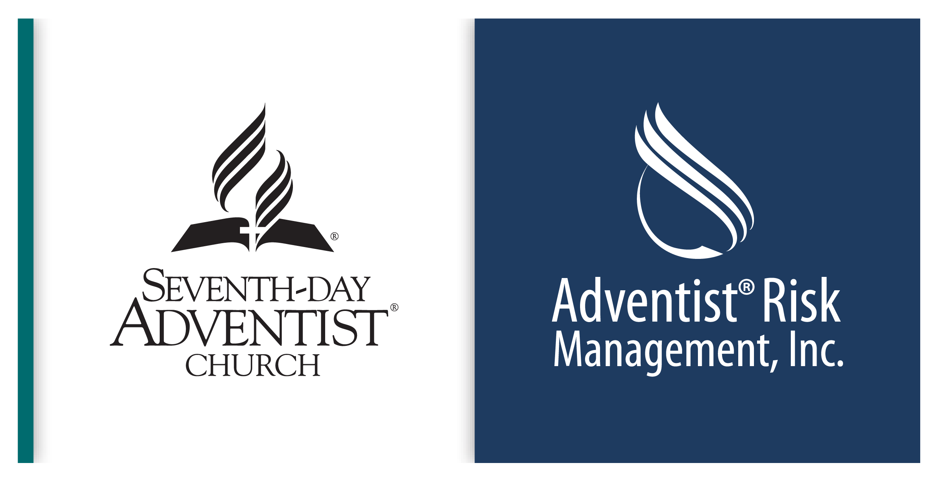
CHILD PROTECTION PLAN RESOURCES
Seventh-day Adventist Church in North America

NAD - YOUTH/CHILDREN’S MINISTRY VOLUNTEER CODE OF CONDUCT

Acknowledgment
Because I want the best possible environment for our children and youth to grow up in, it is important that those working with children have guidelines for conduct in order to protect both themselves and those under their care. As a ministry volunteer, I want parents and others to feel comfortable and confident with me.

My Commitment to Volunteer Ministry
As a Youth/Children’s Ministry Volunteer, I will:

- Provide appropriate adult supervision at all times for the children for whom I am responsible.

- Have at least one other adult, eighteen (18) years of age or older, to help with the supervision of children. If I find myself in a situation where I am the only adult present, under no circumstances will I allow myself to be alone with one child (the “two-person rule”). This protects the child as well as protecting the adult from possible allegations.

- Ask a child’s permission before physically touching him/her anywhere, even when responding to an injury or problem. This is especially true for any areas that would normally be covered by a T-shirt and/or shorts. If an injury is within this area, make sure another adult works with you as care is provided.

- Refrain from physical and verbal attacks and corporal punishment which are inappropriate behaviors and should never be used as discipline. “Time outs” or “sit-in-that-chair” may be helpful discipline methods to use with children.

- Affirm children with appropriate touching by keeping hugs brief and “shoulder-to-shoulder” or “side-to- side.” I will keep hands at (not below) the shoulder level. For small children who like to sit on laps, I will encourage them to sit next to me.

- Provide extra care when taking small children to the restroom. I will take another adult along, or leave the door open.

- Be aware of conducting activities in rooms that do not have an interior viewing area, or I will leave the door open during the activity to allow easy observation by others.

- Cooperate with the volunteer screening process and complete the Volunteer Ministry Information form, as required by the church.

- Be aware of the signs and symptoms of child abuse and aware of the legal requirements for reporting suspected cases of abuse. In addition to any legally required reporting, I agree that if I become aware of any behavior by another individual which seems abusive or inappropriate towards children I am supervising, I will report that behavior to the church pastor, elder, or directly to the Conference Treasurer’s or Risk Management Director.

- Cooperate with church leadership in conducting children and youth ministries by being a volunteer who is loving, kind, firm, and always a thoroughly professional person. Working with children and youth is not only a privilege; it is also a serious responsibility that must be approached with utmost care.

- Participate in orientation and training programs conducted by the church.

- Uphold the standards of the Seventh-day Adventist Church.

* In the event I find it impossible to comply with the above, I will comply as closely as possible with the Code of Conduct and act in good faith for the welfare of the people involved.

Thank You for your service as a Youth/Children’s Ministry Volunteer
Please retain a copy of this document and keep it for reference.

